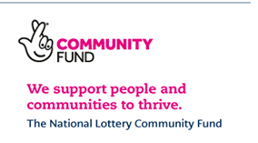
Person Specification
Job Title: Case Worker – Rights and Equality Sandwell (RES)
Candidates will be assessed for shortlist and interviewed against the following criteria.
1 | Qualifications | Essential | Desirable
1.1 | A First Degree and /or Level 6 Professional Qualification in a subject area relevant to Rights, Equality and Inclusion. | x
1.2 | Grade C /Level 4/5 GCSE or equivalent in both English and Maths | x

2 | Experience | Essential | Desirable
2.1 | A proven track record of successfully dealing with case work | x
2.2 | Completing casework to a high quality and standard complying with a Quality Mark eg The Community Legal service quality Mark |  | x
2.3 | Attending multi agency cohesion meetings | x
2.4 | Developing and maintaining strong links with statutory and community and Voluntary Organisations. | x
2.5

3 | Skills and Abilities | Essential | Desirable
3.1 | Excellent Report writing skills | x
3.2 | Ability to advise and assist clients with casework up to tribunal or county court level | x
3.3 | To promote and publicise RES at relevant events

4 | Special Requirements | Essential | Desirable
4.1 | Travel around Sandwell, the Black Country and wider West Midlands area | x
4.2 | To produce quarterly news letters | x
4.3 | Work flexibly to meet the needs of clients, communities and RES.

